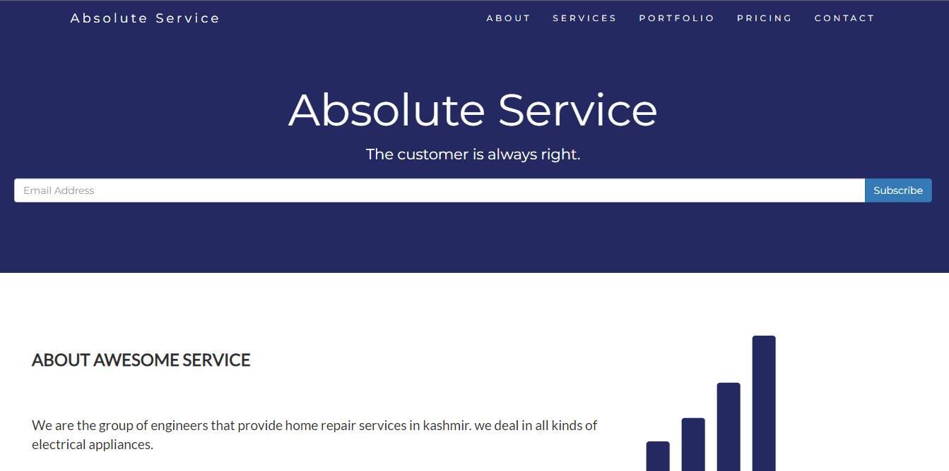

**Project Name: Absolute Service (Home Renovation website)**

**Burhan Mir**

**Presents.**

**Overview**

**Absolute Service (Srinagar) offers specialist architecture, interior designing & construction services. Our company specializes in design and delivery of stylish and contemporary homes, predominantly in exclusive areas of Kashmir division. A few of our key Services: Renovations, modernization and refurbishment projects. Interior Design and architectural planning. Managing and supervising all aspects of the work. Kitchens and Bathrooms including design and installation and get a quote by a click of a button.**

**Goal**

1. **Collapsible nav-bar**
2. **About Section.**
3. **Services Section.**
4. **Portfolio Section.**
5. **Customer review carousel.**
6. **Pricing Section with three pricing cards i.e., basic, pro and premium.**
7. **Contact Section with a contact form containing name, contact and comment section.**

**Technology used**

1. **HTML 5**
2. **CSS 3**
3. **Bootstrap 3**